- Program ID : VM001MA1

- Display Layout
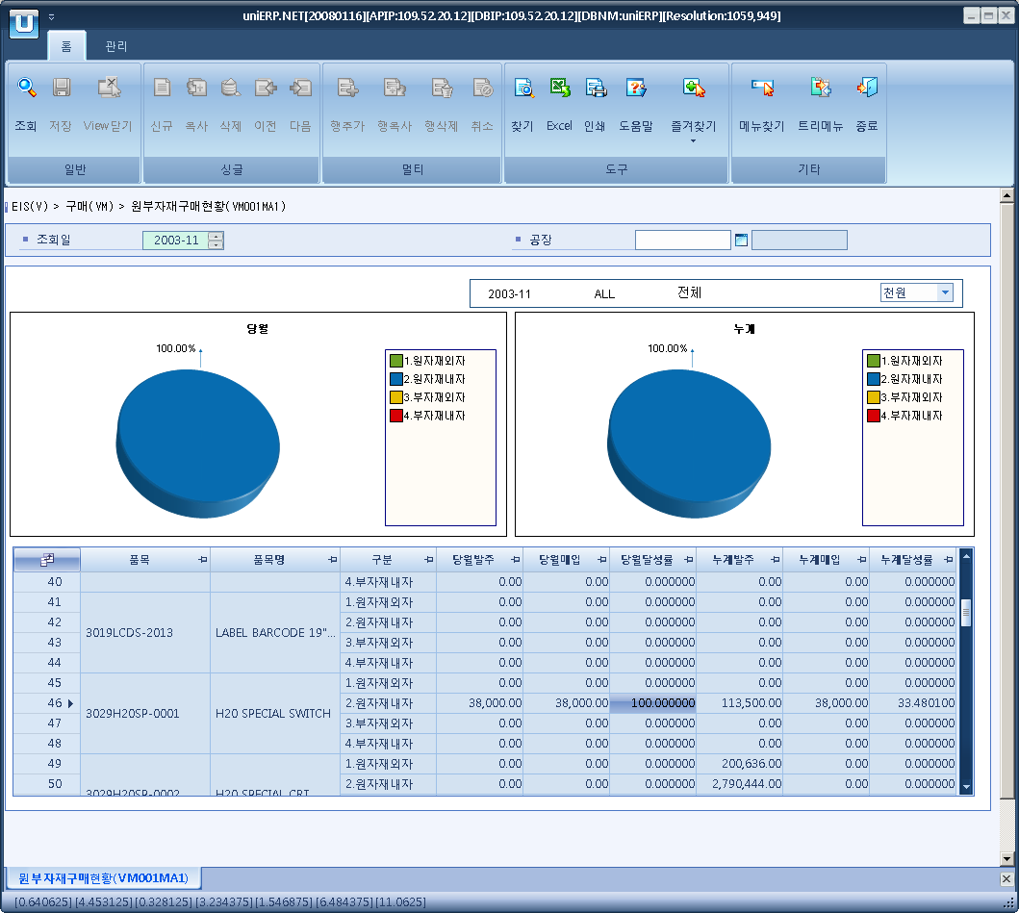

- Event flow
- Click Query button
- OnFncQuery -> DbQuery -> DataChange
- Display Unit combo change
- uniCombo1_ValueChanged -> DataChange

- SQL Statements
- Material puchase result
SELECT a.item_cd, a.item_nm, a.flag,
a.cur_po, a.cur_iv, CASE WHEN a.cur_po = 0 THEN 0 ELSE a.cur_iv / a.cur_po * 100 END AS cur_rate,
a.sum_po, a.sum_iv, CASE WHEN a.sum_po = 0 THEN 0 ELSE a.sum_iv / a.sum_po * 100 END AS sum_rate
FROM (SELECT a.item_cd, b.item_nm, c.flag,
ISNULL(SUM(CASE WHEN a.flag = c.flag THEN a.cur_po ELSE 0 END), 0) AS cur_po, -- 당월발주
ISNULL(SUM(CASE WHEN a.flag = c.flag THEN a.cur_iv ELSE 0 END), 0) AS cur_iv, -- 당월매입
ISNULL(SUM(CASE WHEN a.flag = c.flag THEN a.sum_po ELSE 0 END), 0) AS sum_po, -- 당월발주
ISNULL(SUM(CASE WHEN a.flag = c.flag THEN a.sum_iv ELSE 0 END), 0) AS sum_iv -- 당월매입
FROM (SELECT b.item_cd,
CASE WHEN c.item_acct = '30' AND d.import_flg = 'Y' THEN '1.원자재외자'
WHEN c.item_acct = '30' AND d.import_flg = 'N' THEN '2.원자재내자'
WHEN c.item_acct = '35' AND d.import_flg = 'Y' THEN '3.부자재외자'
WHEN c.item_acct = '35' AND d.import_flg = 'N' THEN '4.부자재내자'
END AS flag,
SUM(CASE WHEN CONVERT(VARCHAR(6), a.po_dt, 112) = @strYyyymm THEN b.po_loc_amt ELSE 0 END) AS cur_po, 0 AS cur_iv, SUM(b.po_loc_amt) AS sum_po, 0 AS sum_iv
FROM m_pur_ord_hdr a INNER JOIN m_pur_ord_dtl b ON b.po_no = a.po_no
INNER JOIN b_item_by_plant c ON c.plant_cd = b.plant_cd
AND c.item_cd = b.item_cd
AND c.item_acct IN ('30','35')
AND c.plant_cd LIKE @strPlantCd
INNER JOIN m_config_process d
ON d.po_type_cd = a.po_type_cd
WHERE a.po_dt >= SUBSTRING(@strYyyymm, 1, 4) + '0101'
AND a.po_dt < DATEADD(MONTH, 1, @strYyyymm + '01')
GROUP BY b.item_cd, c.item_acct, d.import_flg
UNION ALL
SELECT b.item_cd,
CASE WHEN c.item_acct = '30' AND d.import_flg = 'Y' THEN '1.원자재외자'
WHEN c.item_acct = '30' AND d.import_flg = 'N' THEN '2.원자재내자'
WHEN c.item_acct = '35' AND d.import_flg = 'Y' THEN '3.부자재외자'
WHEN c.item_acct = '35' AND d.import_flg = 'N' THEN '4.부자재내자'
END AS flag, 0 AS cur_po,
SUM(CASE WHEN CONVERT(VARCHAR(6), a.iv_dt, 112) = @strYyyymm THEN b.iv_loc_amt ELSE 0 END) AS cur_iv, 0 AS sum_po, SUM(b.iv_loc_amt) AS sum_iv
FROM m_iv_hdr a INNER JOIN m_iv_dtl b ON b.iv_no = a.iv_no INNER JOIN b_item_by_plant c
ON c.plant_cd = b.plant_cd AND c.item_cd = b.item_cd AND c.item_acct IN ('30','35')
AND c.plant_cd LIKE @strPlantCd
INNER JOIN m_iv_type d
ON d.iv_type_cd = a.iv_type_cd
WHERE a.iv_dt >= SUBSTRING(@strYyyymm, 1, 4) + '0101'
AND a.iv_dt < DATEADD(MONTH, 1, @strYyyymm + '01')
AND a.posted_flg = 'Y'
GROUP BY b.item_cd,
CASE WHEN c.item_acct = '30' AND d.import_flg = 'Y' THEN '1.원자재외자'
WHEN c.item_acct = '30' AND d.import_flg = 'N' THEN '2.원자재내자'
WHEN c.item_acct = '35' AND d.import_flg = 'Y' THEN '3.부자재외자'
WHEN c.item_acct = '35' AND d.import_flg = 'N' THEN '4.부자재내자'
END) a
INNER JOIN b_item b
ON b.item_cd = a.item_cd
CROSS JOIN (SELECT '1.원자재외자' AS flag UNION ALL SELECT '2.원자재내자'
UNION ALL SELECT '3.부자재외자' UNION ALL SELECT '4.부자재내자') c
GROUP BY a.item_cd, b.item_nm, c.flag) a
ORDER BY a.item_cd, a.item_nm, a.flag

